CURRICULUM VITAE

VIVEK KUMAR YADAV
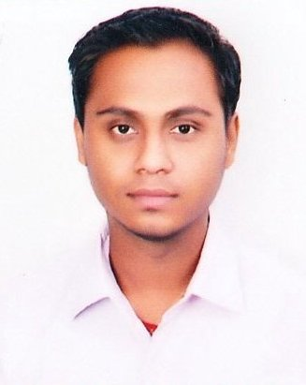
Address : LIG-165, BHARTI NIKETAN GOVINDPURA
BHOPAL (M.P) 462023
Contact No. : +919039860712
E-mail : vivekkumaryadav86@yahoo.com

OBJECTIVE:

   ➢ To work in related areas of ELECTRICAL ENGINEERING.
   ➢ Field and willing to face any type of challenge that comes my way.
WORK EXPERIENCE:
   ➢  Bharat Heavy Electricals Limited (Bhopal) 1 yr as a Graduate apprentice
(Engg. Trainee) in the Transformer Department.

SEMINAR DELIVERED

➢  VIRTUAL KEYBOARD
➢  GPRS
PROJECTS:
MINOR PROJECT
   ➢  SPEED CONTROL OF D.C. MOTOR
MAJOR PROJECT
   ➢ STUDY OF 132KV SUBSTATION & ITS COMPONENTS
TRAININGS:
  ➢  I have done my Vocational or College level Training from BHEL Limited &.
MPPKVL BHOPAL both for 30 days.
INDUSTRIAL VISIT
  ➢ Bharat Heavy Electricals Limited, Bhopal
Hobbies
  ➢ Travel, Interact with new person & cricket
EDUCATIONAL QUALIFICATION:
COURSE | YEAR | UNIVERSITY/BOARD | DIVISION | %
B.E | 2010 | R.G.P.V BHOPAL (M.P.) | FIRST | 67.94%
12th | 2005 | M.P.BOARD(RAMAN HIGHER SECONDARY SCHOOL GOVINDPURA BHOPAL) | FIRST | 65.60%
10th | 2003 | M.P. BOARD (RAMAN HIGHER SECONDARY SCHOOL GOVINDPURA BHOPAL) | FIRST | 60.00%

PERSONAL DETAILS.
Name : VIVEK KUMAR YADAV
Date of Birth : 17-03-1987
Father’s name : SHRI R.B.YADAV
Address : LIG-165, BHARTI NIKETAN GOVINDPURA BHOPAL (M P)
Contact no. : +919039860712
E-mail : vivekkumaryadav86@yahoo.com

DECLARATION
I hereby declare that the above written particulars are true to the best of my knowledge.

DATE - VIVEK KUMAR YADAV
PLACE - BHOPAL

